# 2. USER MANUAL

This document guides you how to use KarryWell client-web application for admin. You will need only 10 minutes to learn.

## 2.1. Select a screen

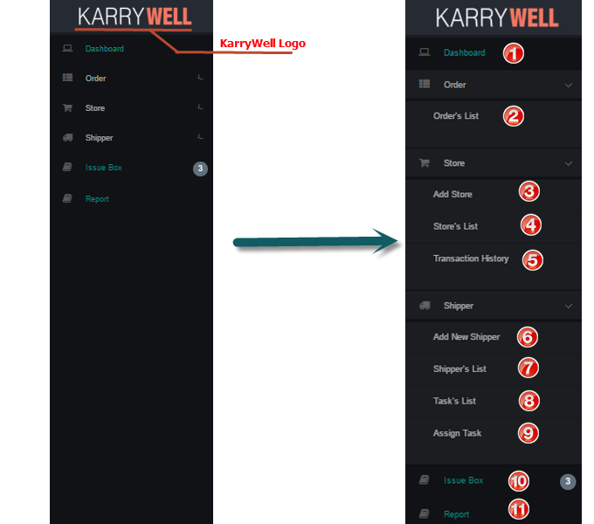

**To select a screen**

1. Click on screen that you want to go on left navigate bar

* ➊Dashboard: used to view statistics and overview of system
* ➋Order’s List: used to view all orders and related information
* ➌ Add Store: used to add new Store to system
* ➍Store’s List : used to view all Store, block store and confirm payment
* ➎Transaction History: used to view all transactions
* ➏Add Shipper: used to add new Shipper to system
* ➐Shipper’s List: used to view all Shipper and related information
* ➑Task’s List: used to view all Tasks and related information
* ➒Assign Task: used to assign order to shipper
* ➓IssueBox: used to view and resolve issue
* ⓫Report: used to view statistics about system by month, year

## 2.2. Add new Store

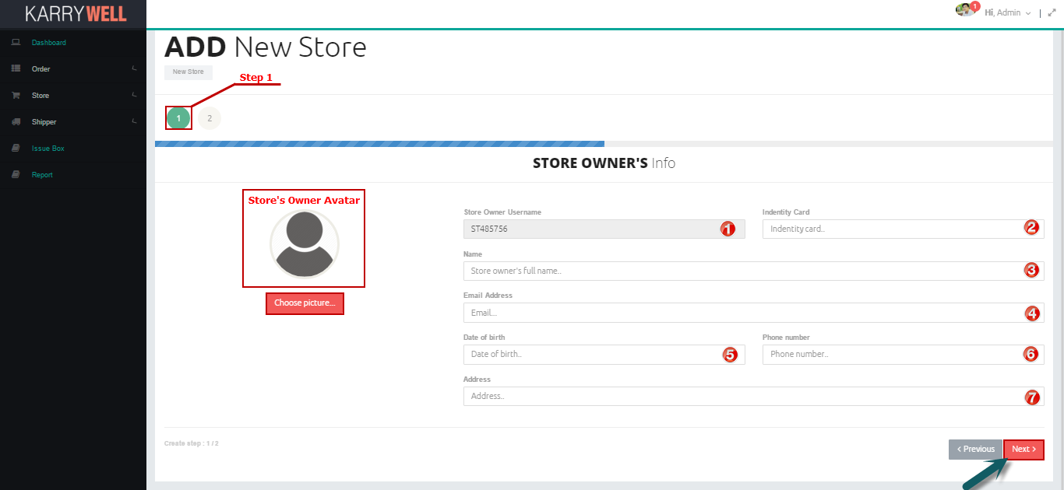

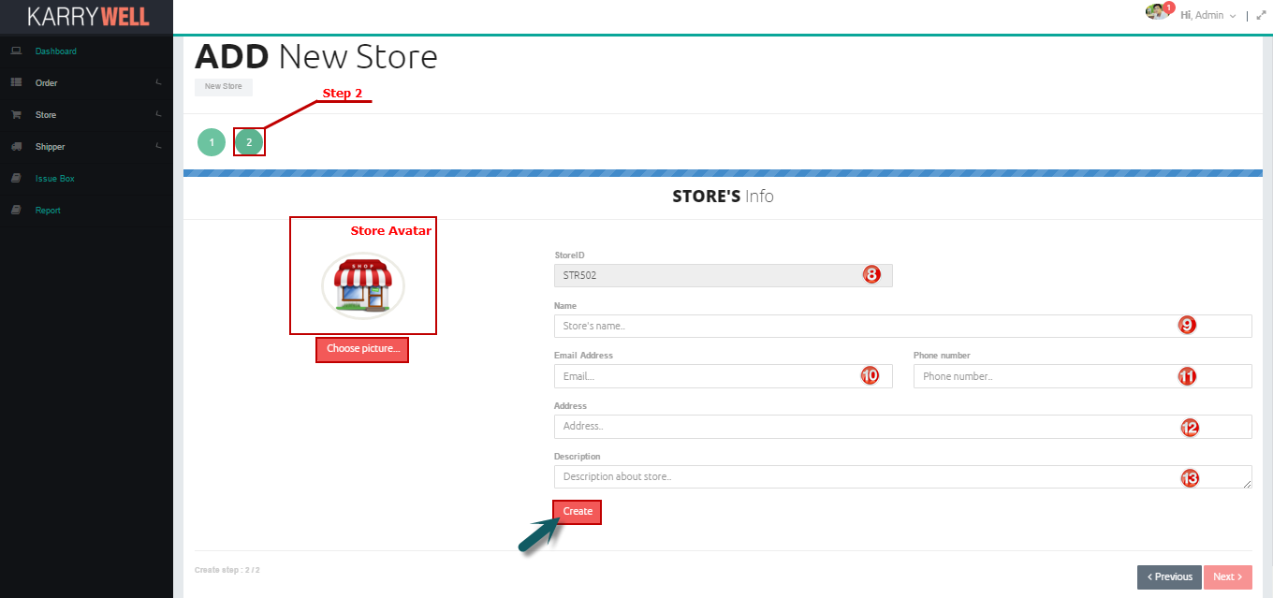

**To add new Store**

1. Open “Add Store” Screen
2. Enter valid store owner information into textbox, choose avatar if it is necessary:

* Identity card➋: identity card of store’s owner, user have to enter a string of digits from 9 to 12 characters
* Name➌: Full name of store’s owner
* Email➍: Email of store’s owner, must follow email format
* Date of Birth➎: date of birth of store’s owner, click into textbox, a calendar will be showed, user click into day in calendar to pick.
* Phone Number➏: phone number of store’s owner, user have to enter a string of digits from 11 to 12 characters
* Address➐: detail address of store’s owner

1. Click Next button
2. Enter valid store information into textbox, choose avatar if it is necessary

* Name➒: Full name of store
* Email➓: Email of store, must follow email format
* Phone Number⓫: phone number of store, user have to enter a string of digits from 11 to 12 characters
* Address⓬: detail address of store
* Description⓭: description about store

1. Click Create button

## 2.3. Add new Shipper

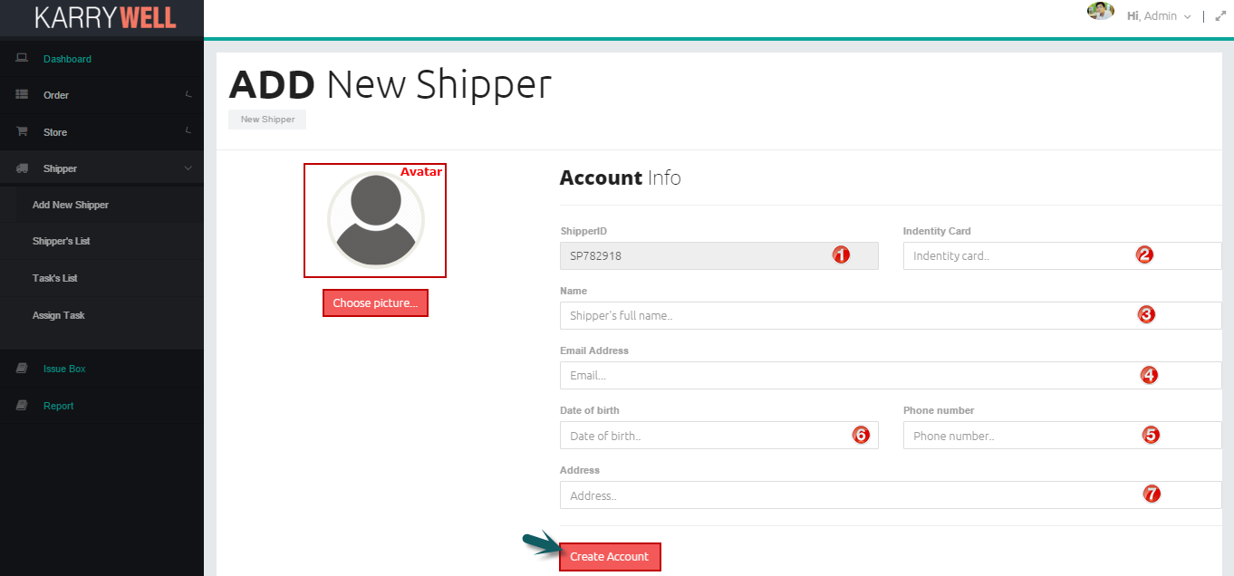

**To add new Shipper**

1. Open “Add Shipper” Screen
2. Enter valid shipper information into textbox, choose avatar if it is necessary

* Identity card ➋: identity card of shipper, user have to enter a string of digits from 9 to 12 characters
* Name ➌: Full name of shipper
* Email➍: Email of shipper, must follow email format
* Date of Birth➏: date of birth of shipper, click into textbox, a calendar will be showed, user click into day in calendar to pick.
* Phone Number➎: phone number of shipper, user have to enter a string of digits from 11 to 12 characters
* Address➐: detail address of shipper

1. Click Create button

## 2.3. Confirm Payment

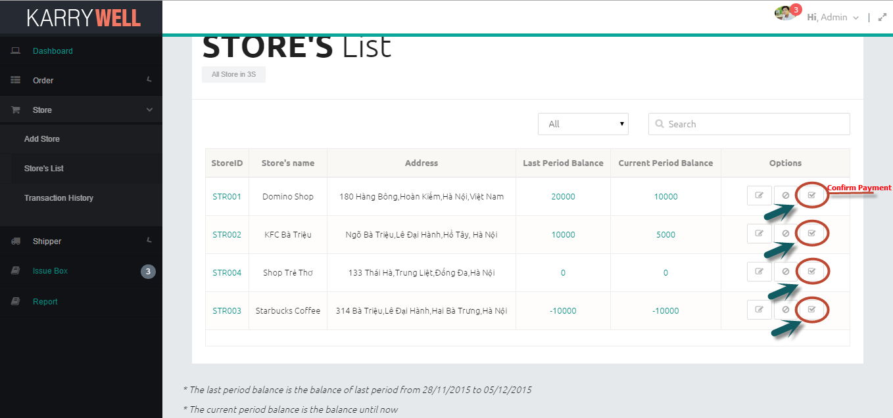

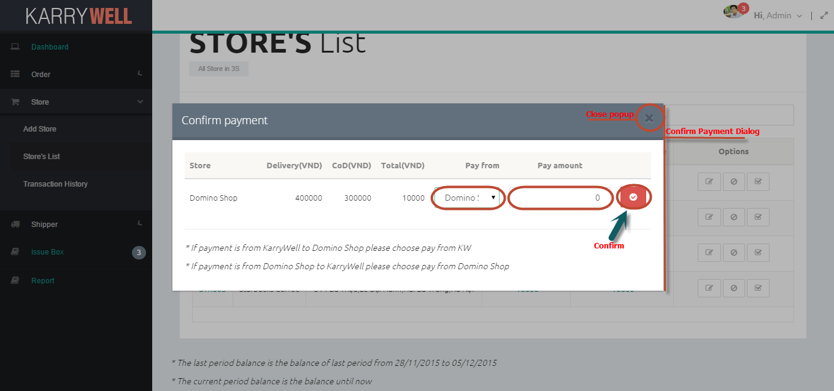

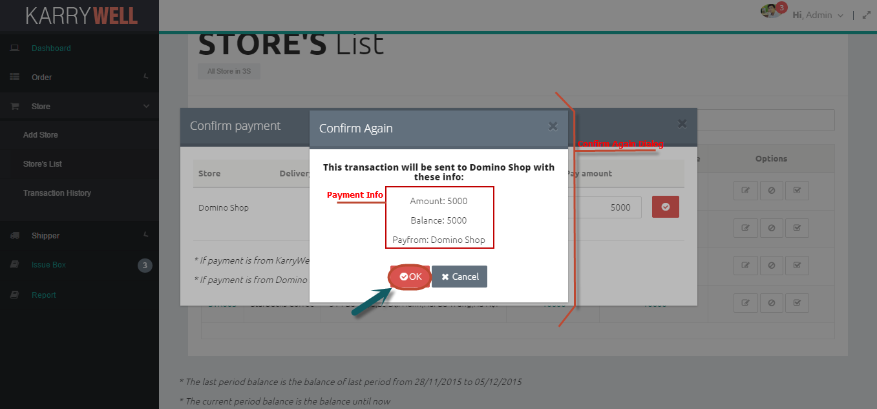

**To confirm payment**

1. Open “Store’s List” Screen
2. Click on Confirm Payment icon button
3. After confirm payment popup is showed:

* Pick payfrom drop-down list ➊:

+ If pick KarryWell, this payment is from system to store

+ If pick store’s name, this payment if from store to system

* Enter amount ➋ of payment, amount must be digits and not equal 0

1. Click on button Confirm
2. After Confirm Again popup is showed, user read payment information carefully then click “OK” button to add this transaction or cancel to close this popup

## 2.4. Block/Unblock Store

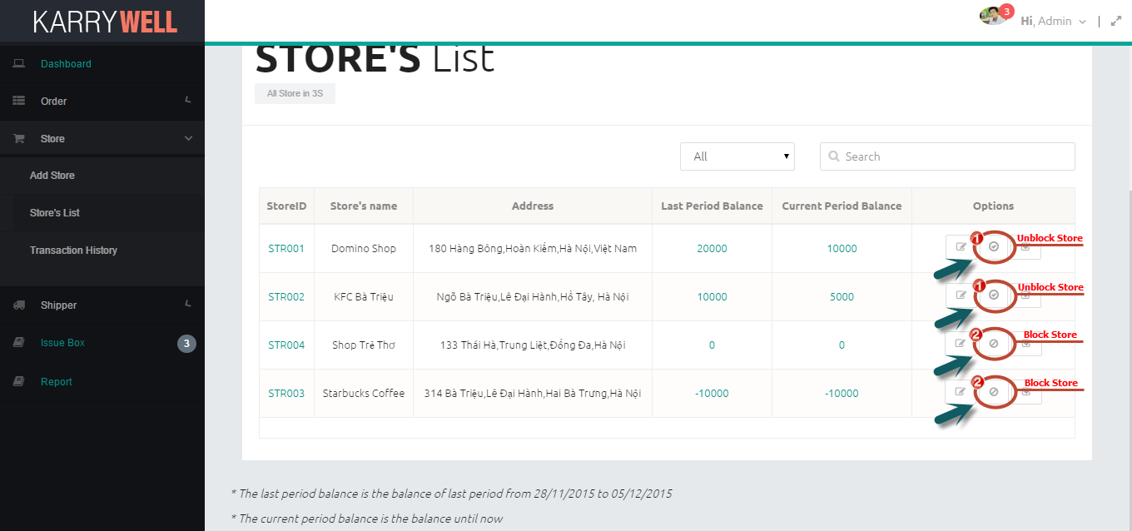

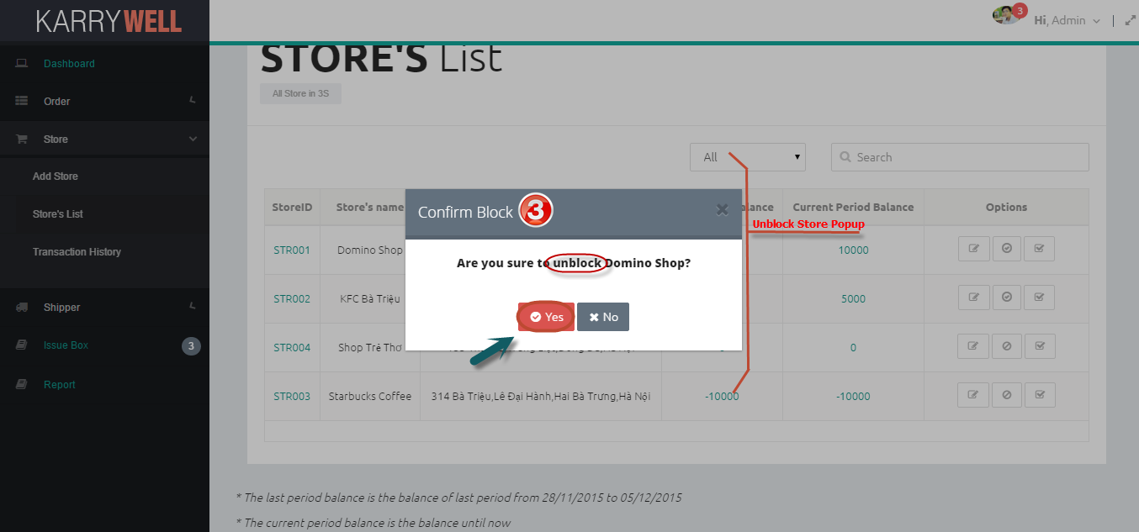

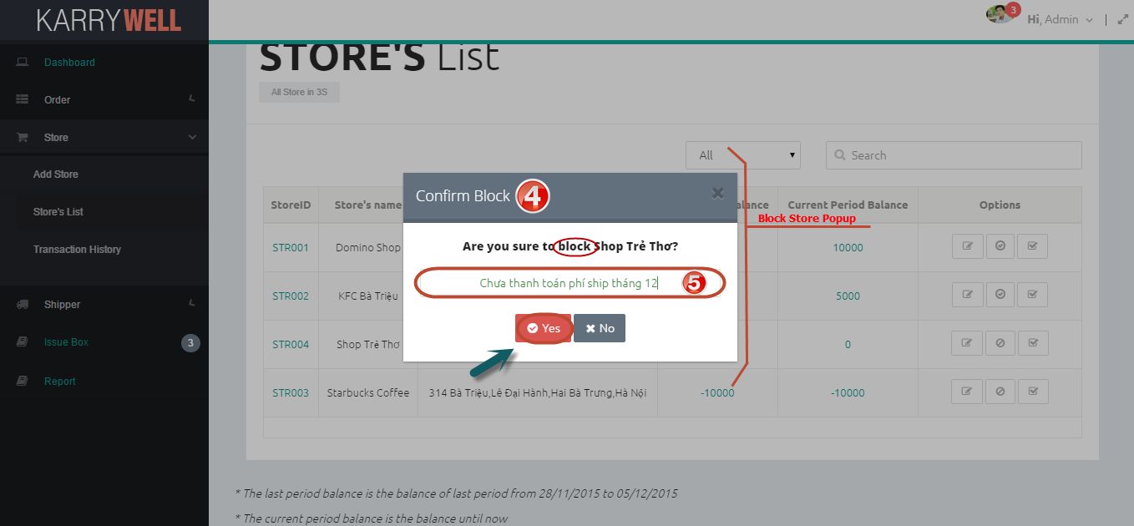

**To block/unblock store**

1. Open “Store’s List” Screen
2. Click on Block ➊ or Unblock ➋ store icon button
3. A popup will be showed:

* If Unblock Popup ➌ is showed, user click button “Yes” to unblock this store or “No” to close popup
* If Block Popup ➍ is showed, user enter reason in reason textbox ➎ (not blank) then click button “Yes” to block this store or “No” to close popup.

## 2.5. Assign Task

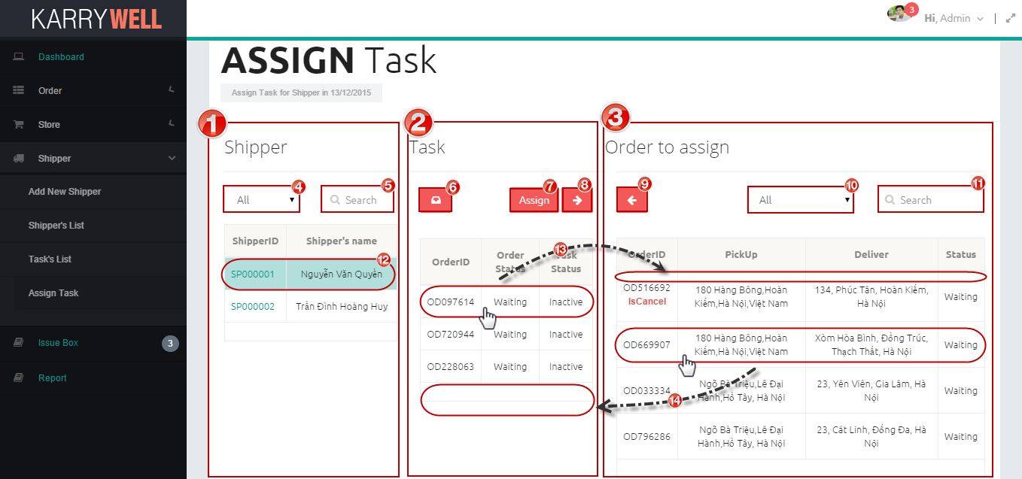

**Screen Description:**

1. Shipper area ➊: includes all shippers, textbox and filter for search shipper

* Filter ➍: user can pick type to search shippers by name, id or both
* Search ➎: user type search key to search shipper
* ⓬ When user select a row of shipper, all tasks of this shipper that can be assigned for other shipper will be listed in task table

1. Task area ➋: includes all tasks that can be assigned for other shipper and function buttons:

* IssueBox ➏: click to go to IssueBox page
* Assign➐: Click to assign task
* Move all to left➑: Move all order of picked shipper to Order table
* ⓭ When user pick task in a row of task table, order of this row will be moved from task table to order table

1. Order Area ➌: includes all orders can be assigned for shipper in order table, textbox and filter for search order:

* Filter ➓: user can pick type to search orders by id, address, status or all
* Search⓫ : user type search key to search order
* Move all to right➒: Move all order in Order table to task table
* ⓮ When user pick order in a row of order table, order of this row will be moved from order table to task table

**To assign task for Shipper**

1. Open “Assign Task” Screen
2. Select Shipper to assign by select row of shipper table ⓬
3. Pick order for shipper by select order on order table ⓮. User also can cancel task by select row of task in task table ⓭, but task is cancelled must be assigned for other shipper.

User can user button move all ➑➒ to pick order and task faster.

1. Click Assign button to assign tasks for shippers

## 2.6. Resolve Issue

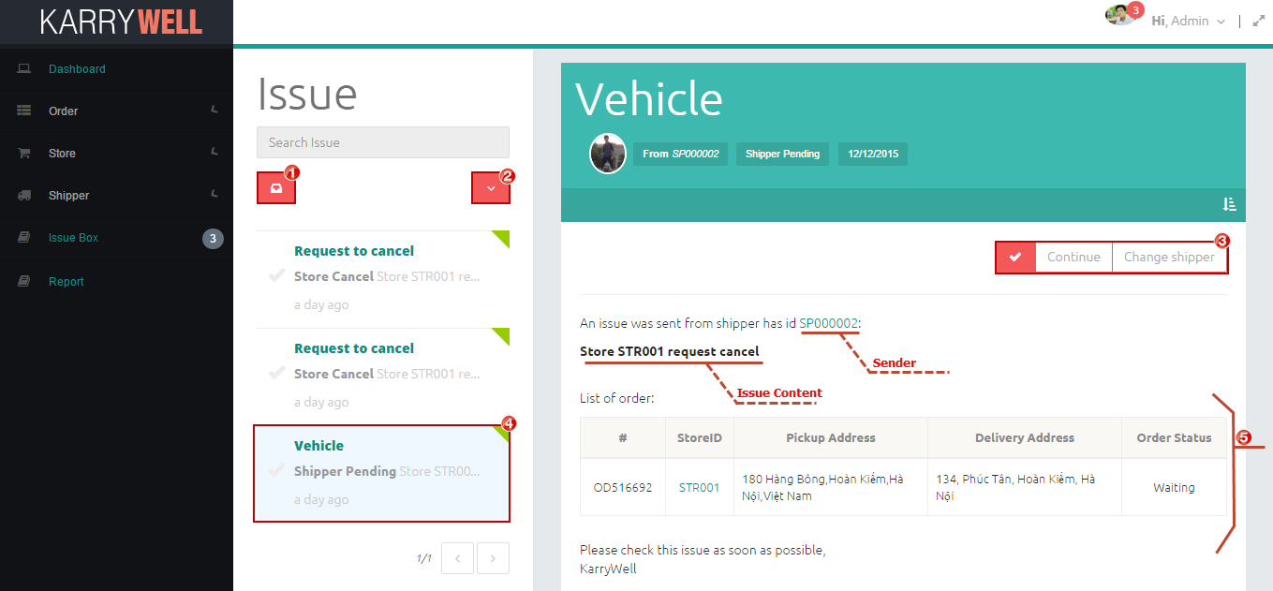

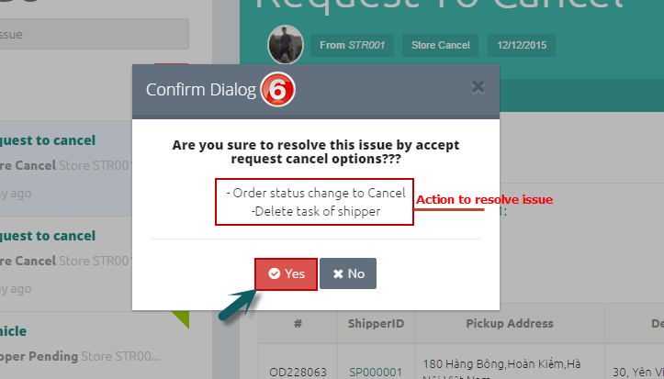 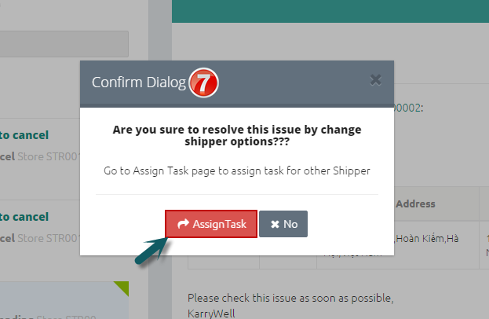

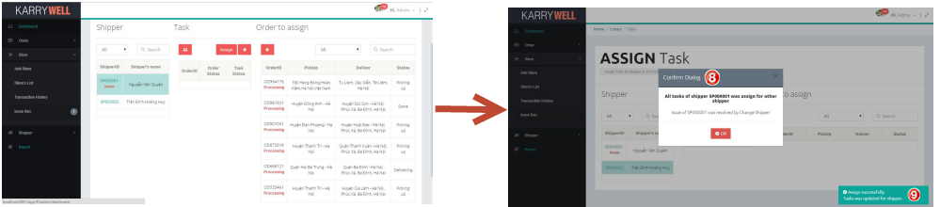

**Screen Description:**

1. Click ➊ to list all issues
2. Filter ➋: Click to view only selected type of issue, includes: Resolved, Unresolved, Shipper Pending, Shipper Cancel, Store Cancel
3. Click on button of resolve type ➌ to resolve issue, there are 3 types:

* Continue: for Shipper Pending issue, allow shipper continue orders which get issue
* Change Shipper: for Shipper Pending issue, change orders to other shipper
* Accept Request: for Shipper Cancel and Store Cancel, accept cancel request

1. Issue ➍: include type (hyperlink), category, content and resolve icon (✓) (is yellow if issue was resolved). User can click on type to view issue detail
2. ➎ List of orders that get issue

**To resolve issue**

1. Open “IssueBox” Screen
2. Pick issue on issue list to resolve
3. After reading content of issue carefully, user choose type of resolve: Continue, Change Shipper or Accept Request
4. A popup will be showed:

* If resolve type is Continue and Accept Request, a popup ➏ shows what system do to resolve issue, then user click “Yes” button to resolve issue or click “No” button to close popup
* If resolve type is Change Shipper:

+ Click “Assign Task” button on popup ➐ to go to Assign page

+ Assign Task for other Shipper (read user manual 2.5 for more detail)

+ After assign, if all issue orders of shipper is assigned for other shipper, a notify popup ➑ and notify message ➒ will be showed. User click “OK” button to back to IssueBox Screen

## 2.7. Search

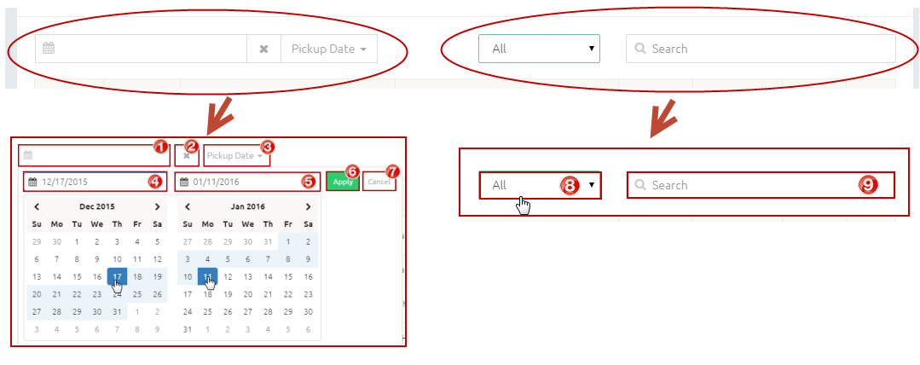

In each view list screen, there is a search tool to help user to search faster

**Screen Description:**

1. Click ➊ to show calendar to pick date
2. Click ➋ to clear date in textbox ➊
3. Click ➌ to choose which type of date will be searched, and some screens don’t have this
4. ➍ Start Date of date range
5. ➎End Date of date range
6. Click ➏ to apply date range after choose start date and end date
7. Click ➐ to Cancel
8. Click ➑ to show filter for search
9. Enter search key into textbox ➒ to search

**To search by date range**

1. Choose date type ➋. If screen doesn’t have drop down list ➋, default type of search date is which type of date in table below
2. Click date range textbox ➊ to pick date
3. Click start date and end date
4. Click “Apply” button ➏, then result will be displayed

**To search by word**

1. Choose type to filter ➑. “All” is search by all information in table below
2. Enter search key into textbox ➒. Whenever type any key in search textbox, result will be displayed immediately

## 2.7. View Detail

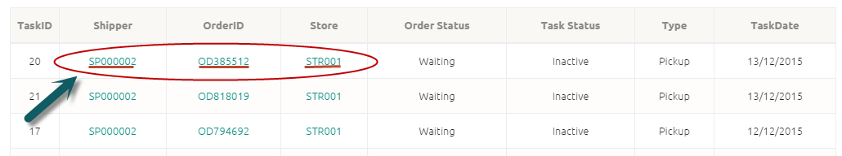

In each view list screen, there are hyperlink to store detail, order detail, shipper’s profile. User just click to this hyperlink to view detail